Catch Duke Lab
(Unit 2)

On the class website, under the Labs/Unit 2/CatchDuke folder you should find the following files:
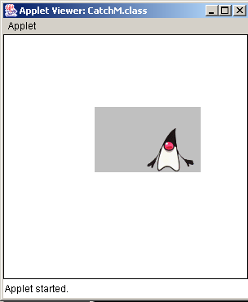
StudentCatchM.html
StudentCatchM.java
duke.gif
sounds/ouch.au
sound/haha.au

The code is already written for you. Unfortunately, there are some errors. This code will not compile. Find and fix the syntax errors.

When your program finally compiles, create an appropriate HTML file and test the applet. You will notice that there is no sound for errors. Fix this bug. Recompile and test your applet. You should be permitted to chase Duke around the applet and hit him with your cursor. When you hit him you should get a sound and when you miss you should get a different sound.

Catch Duke Syntax Lab
(A Chapter 5)

Execute your Catch Duke applet and try to catch Duke.

Animal to Select | Expected Result | Score (15 points each)
Hit Duke | Ouch sound
Miss Duke | Missed sound
Total:

Code Review ( 5 points each):

_______ Method Comments

_______ Line comments within Methods (including /* Modification notices */)

_______ Variable/Field Names appropriate

_______ Formatting (indentation and spacing)

____________ TOTAL SCORE

